IPD9  
Proposal for Team project

Mini Media Player

|  |  |  |  |
| --- | --- | --- | --- |
| **Project Name** | Mini Media Player (MMP) | | |
| **Team Number** | Yang Jun Chen Chen | | |
| **Project Sponsor** |  | | |
| **Author(s)** |  | | |
| **Date:** | [2017-04-09] | | |
| **File No:** | P001 | | |
| **Project Description** | We want to design a mini media player which is playing almost every computer media (sound and video) file and can arrange all media files on user’s computer. For audio, the most common format is the [MP3](http://www.computerhope.com/jargon/m/mp3.htm) file, which is supported by the Windows Media Player. It also supports file formats like [WMV](http://www.computerhope.com/jargon/w/wmv.htm), [WMA](http://www.computerhope.com/jargon/w/wma.htm), [WAV](http://www.computerhope.com/jargon/w/wav.htm) and ACE. | | |
|  | | | |
| **Revision History** | | Author | Date |
|  | |  | [yyyy-mm-dd] |
|  | |  |  |
|  | |  |  |

# Part 1 Overview

## Project Background and Description

Our team’s name is C&Y. Our object is to design and create a windows music player. Team number is Yang, Jun and Chen, Chen. We want to design a mini media player which is playing almost every computer media (sound and video) file and can arrange all media files on user’s computer. For audio, the most common format is the [MP3](http://www.computerhope.com/jargon/m/mp3.htm) file, which is supported by the Windows Media Player. It also supports file formats like [WMV](http://www.computerhope.com/jargon/w/wmv.htm), [WMA](http://www.computerhope.com/jargon/w/wma.htm), [WAV](http://www.computerhope.com/jargon/w/wav.htm) and ACE.

## Project Scope

For the team project, we will be creating a mini media player which. The brief given to me for the media player contained no restrictions on design, simply that it have the functions of an existing media player. In terms of the audience that the media player is aimed at, there was no specific audience given but I have decided to aim mine at mainly the middle age generation as I felt that there wasn’t really a media player aimed at this audience which is largely becoming a bigger audience in the technology industry in this country. We thought that if we can finish this project and make it work well with no less in functionality, it must be a big challenge for us. The entertainment application or some other basic windows application is not easy. Before we started on the design of my media player, I wanted to gain knowledge on not just what made a media player good and bad but what also would appeal more to my target audience. With this in mind, we looked at several different media players that are available not only windows media play but also on the current market including ITunes, Spotify. Looking at these media players, we found that simple shape and color and the search bar is basic function. The WMP cost more resource so we decided design the smaller one which is consume less memory. We also highlighted that the similar neutral color scheme, with Windows Media Player the only one offering a number of different color schemes. We decided from this research that when designing my media player, we would try to incorporate a neutral color scheme, though adding the possibility of changing color schemes like Windows Media Player depending on how the design goes. We would also design a simple interface so that our target audience will be able to navigate my media player with as little hassle as possible and a unique design which would separate my media player from the WMP and iTunes.

## High-Level Requirements

The new application must include the following:

* Ability to allow both internal and external users to downloading any software and install the application
* Ability to interface with the existing database which is in Azure
* Having following function and work well

| **Function** | **Developer** | **Tester(Quality Assurance)** |
| --- | --- | --- |
| Play audio |  |  |
| Play video |  |  |
| Change schema |  |  |
| Search bar |  |  |
| Arrange media files |  |  |
| Create music library |  |  |
| Display the timer |  |  |
| Display set up |  |  |

## Possible Technologies

|  |  |
| --- | --- |
| Possible technologies | Checked |
| LINQ (filter to find a song) |  |
| Ribbon instead menus |  |
| Stack Panel, Grid Splitter (highly recommended) |  |
| Sound, Animation (to play the music) |  |
| Printing (print the lyrics or list) |  |
| Installer (recommended as the finishing touch) |  |
| Storing binary data (pictures, etc.) in a BLOB (cover of the album) |  |

## Special Features

## Additional Libraries & Challenging Items

Installer

# Part 2 screenshots of program window

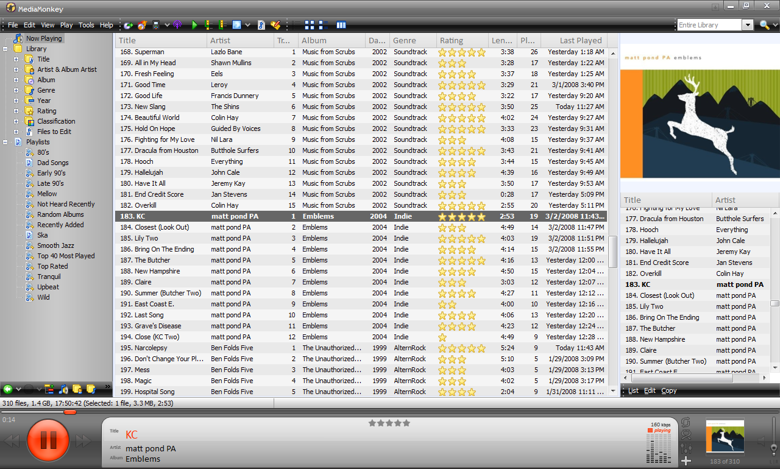

# Part3 Design of Database



## High-Level Timeline/Schedule

|  |  |
| --- | --- |
| Milestone | Estimated Completion Date |
| Project Proposal Approved | [Month] [Day] |
| Tools Installation and development tools completed |  |
| Design complete |  |
| Coding complete |  |
| Testing and Sign-off completed |  |
| Team project management document completed |  |
| Measurements completed |  |
| Project closed |  |
| Presentation |  |

# Important Link

Reference

<http://www.wpf-tutorial.com/audio-video/how-to-creating-a-complete-audio-video-player/>

[https://github.com/mono/taglib-sharp](https://www.google.com/url?q=https%3A%2F%2Fgithub.com%2Fmono%2Ftaglib-sharp&sa=D&sntz=1&usg=AFQjCNGiP6UkNDbir9e5fEeXRKsvMUMTcA)

[https://www.sussex.ac.uk/webteam/gateway/file.php?name=barber-rep&site=20](https://www.google.com/url?q=https%3A%2F%2Fwww.sussex.ac.uk%2Fwebteam%2Fgateway%2Ffile.php%3Fname%3Dbarber-rep%26site%3D20&sa=D&sntz=1&usg=AFQjCNGUBk8oRuYfk37EtFFdxJ5pXMWHuw)

|  |  |  |
| --- | --- | --- |
| Link | Description | Date |
| <https://trello.com/ipd9cy> | Link to Trello | 2017-04-09 |
| <https://github.com/Jun-Yang/TeamProject.git> | GitHub repository | 2017-04-09 |
| https://portal.azure.com/ | Azure Database | 2017-04-09 |